# Bansilal Ramnath Agarwal Charitable Trust’s

# VISHWAKARMA INSTITUTE OF TECHNOLOGY, PUNE-37

# http://vitmelange.com/img/logo.png(An Autonomous Institute of Savitribai Phule University)

**Department of Artificial Intelligence & Data Science**

|  |  |
| --- | --- |
| Division | AI-A |
| Name | Pranav Doshi |
| Roll.no | 55 |
| PRN | 12211541 |
| Batch | B-2 |

* Basic Commands used in linux:

1. [The](https://www.digitalocean.com/community/tutorials/linux-commands" \l "the-ls-command-in-linux) ls command in Linux

The ls command is used to list files and directories in the current working directory. This is going to be one of the most frequently used Linux commands you must know of.

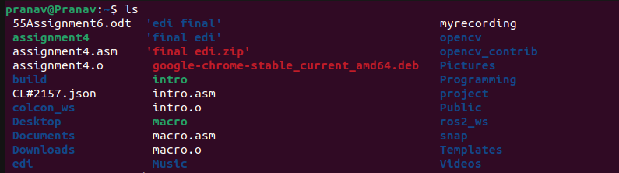

## [The pwd command in Linux](https://www.digitalocean.com/community/tutorials/linux-commands" \l "the-pwd-command-in-linux)

The pwd command allows you to print the current working directory on your terminal. It’s a very basic command and solves its purpose very well.



## mkdir command in Linux

This mkdir command allows you to create fresh directories in the terminal itself. The default syntax is **mkdir <directory name>** and the new directory will be created.

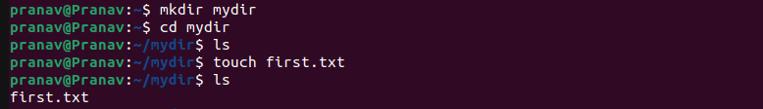

## cd command in Linux

The **cd command** is used to navigate between directories. It requires either the full path or the directory name, depending on your current working directory.



## mv command in Linux

The **mv command** is generally used for renaming the files in Linux.



## uname command in Linux

The **uname command** is used to check the complete OS information of the system.



## cp command in Linux

The **cp command** of Linux is equivalent to copy-paste and cut-paste in Windows.



## cat command in Linux

The **cat command** is the simplest command to use when you want to see the contents of a particular file.



## ps command in Linux

**ps command** in Linux is used to check the active processes in the terminal.

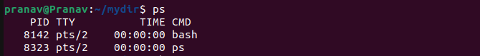

## whoami command in Linux

The **whoami command**provides basic information that is extremely useful when working on multiple systems



1. cal command

**cal** command is a calendar command in Linux which is used to see the calendar of a specific month or a whole year.

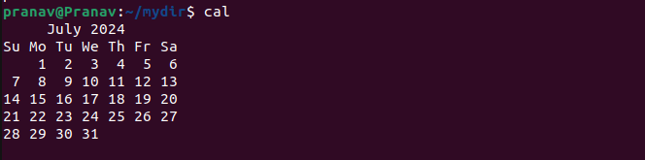

1. echo command

Echo is a Unix/Linux command tool used for displaying lines of text or string which are passed as arguments on the command line



1. passwd command

The passwd command sets and changes passwords for users. Use this command to change your own password or another user's password.

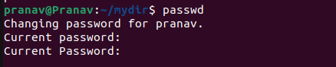

1. rm command

The 'rm' means remove. This command is used to remove a file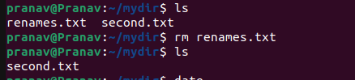.

1. date command

**date**command is used to display the system date and time. date command is also used to set date and time of the system.



1. touch command

The touch command in Linux is used to create a new empty file and to change the timestamps of existing files.

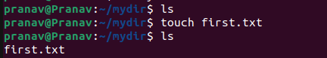

1. man command

man command in Linux is used to display the user manual of any command that we can run on the terminal.



1. Sort command

SORT command is used to sort a file, arranging the records in a particular order.

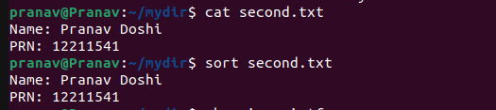

1. Whereis command

*whereis*command is used to find the location of source/binary file of a command and manuals sections for a specified file in Linux system.



1. df command

The df command displays information about total space and available space on a file system.

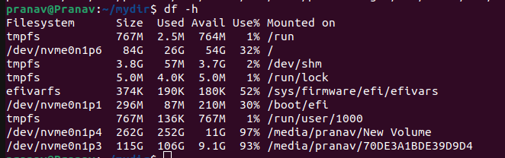

Conclusion:

I learned basic linux commands its execution and use from this assignment.